**Week 7 ReactJS Mandatory HandsOn Solutions**

Exercise-9

Create a React Application named “cricketapp” with the following components:

**ListofPlayers.js**

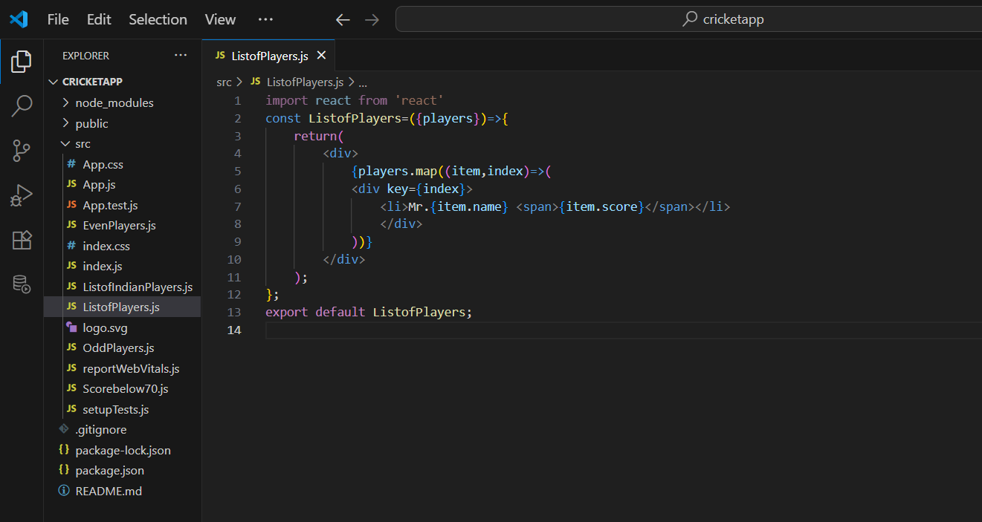

Scorebelow70.js

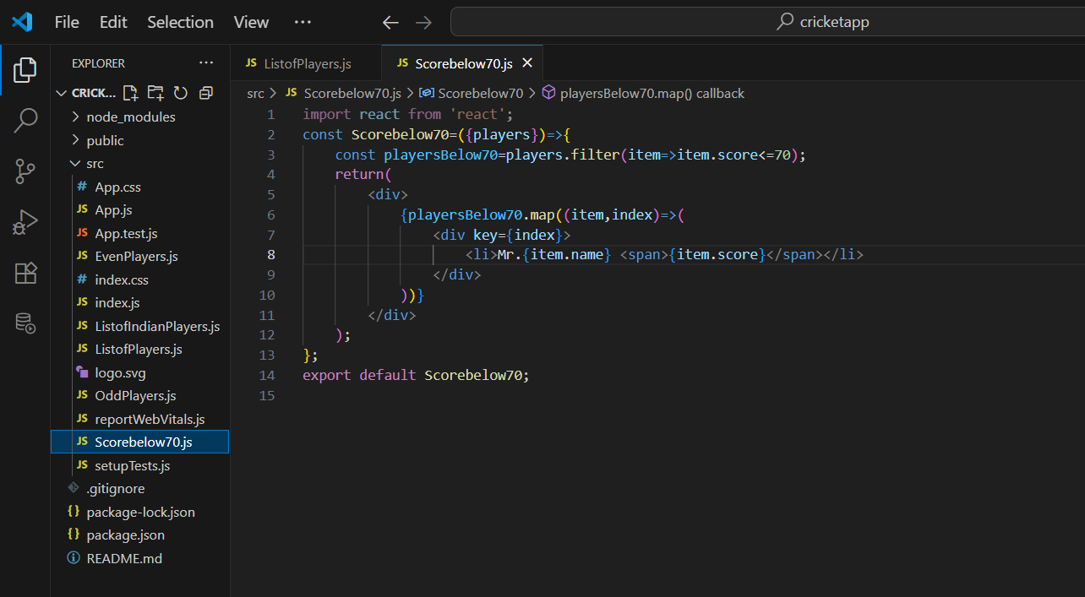

OddPlayers.js

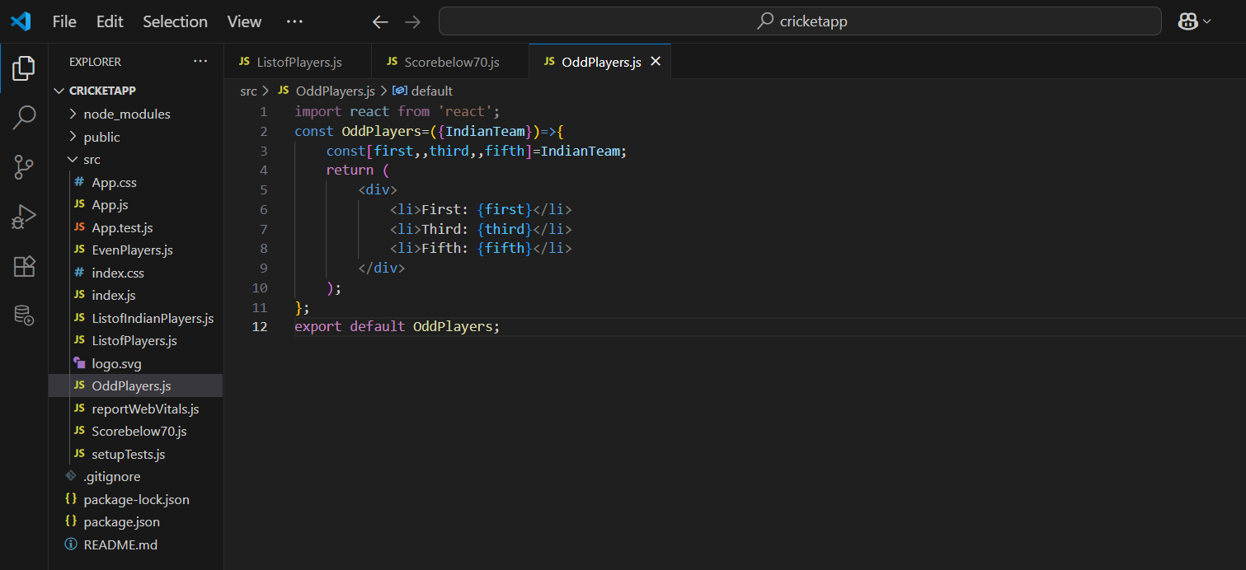

EvenPlayers.js

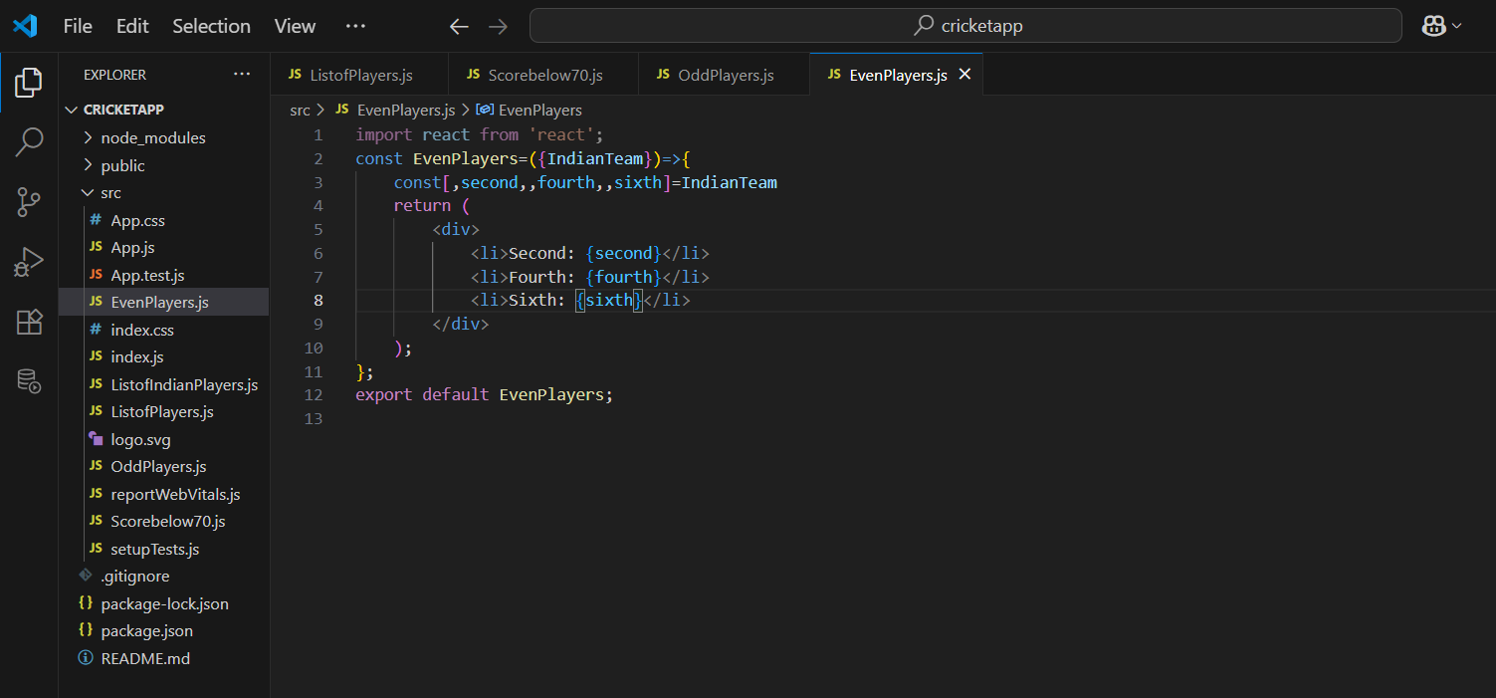

ListofIndianPlayers.js

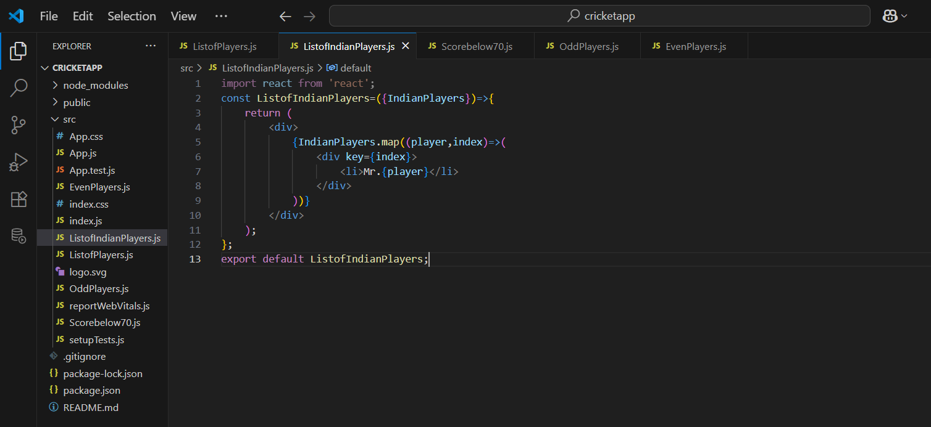

App.js

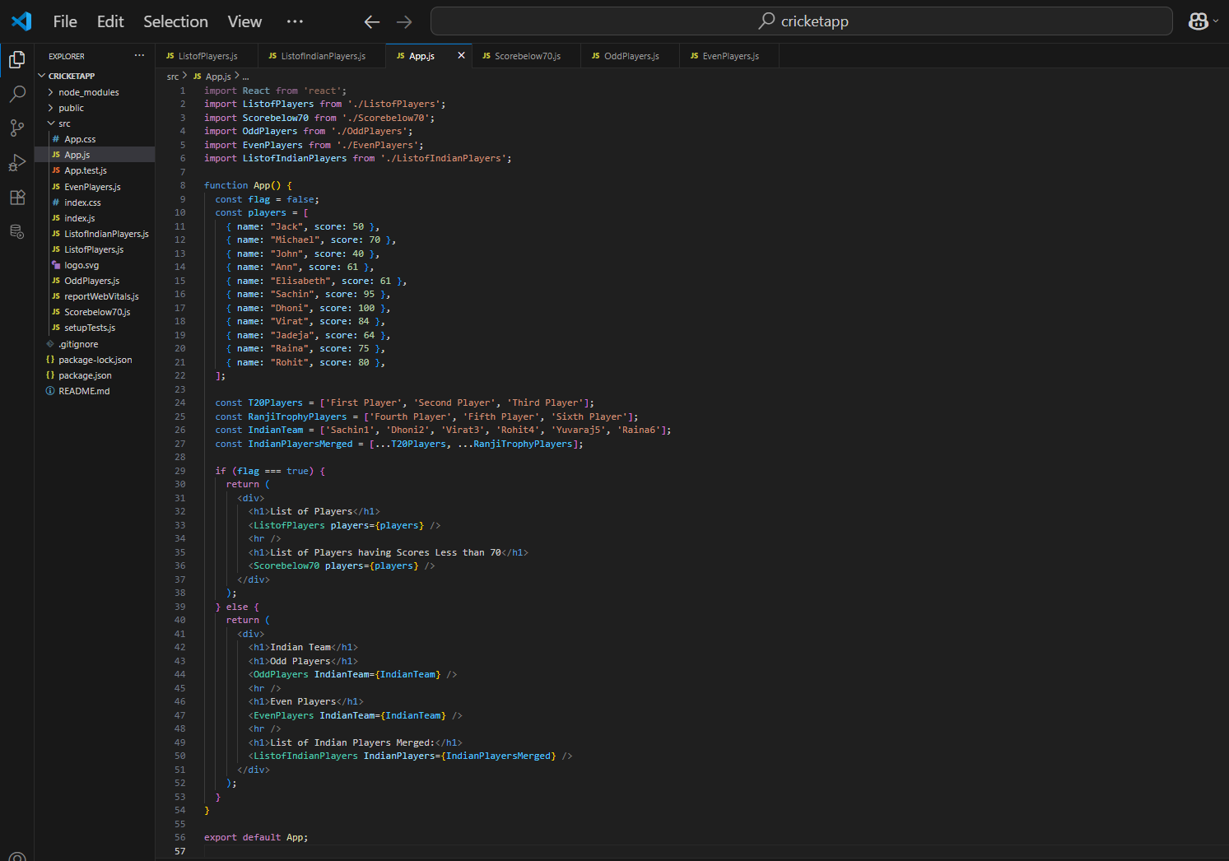

Output:

When flag==True

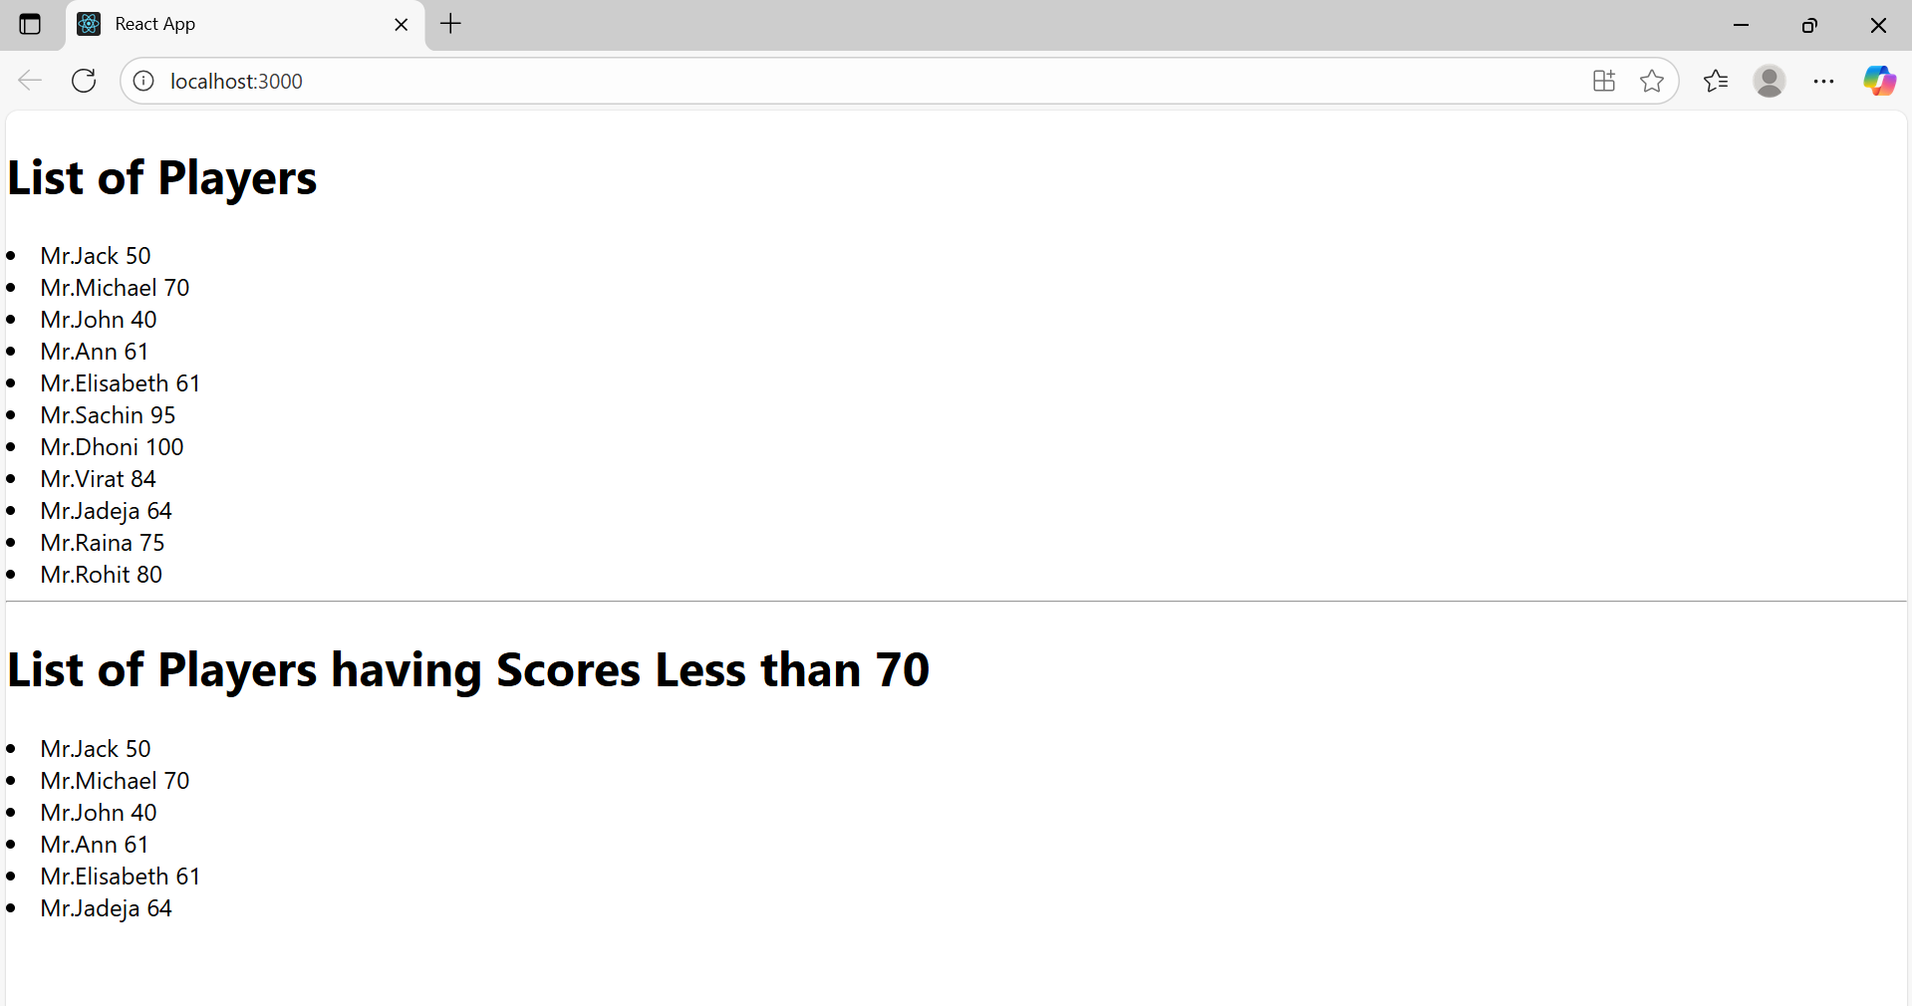

When Flag==False

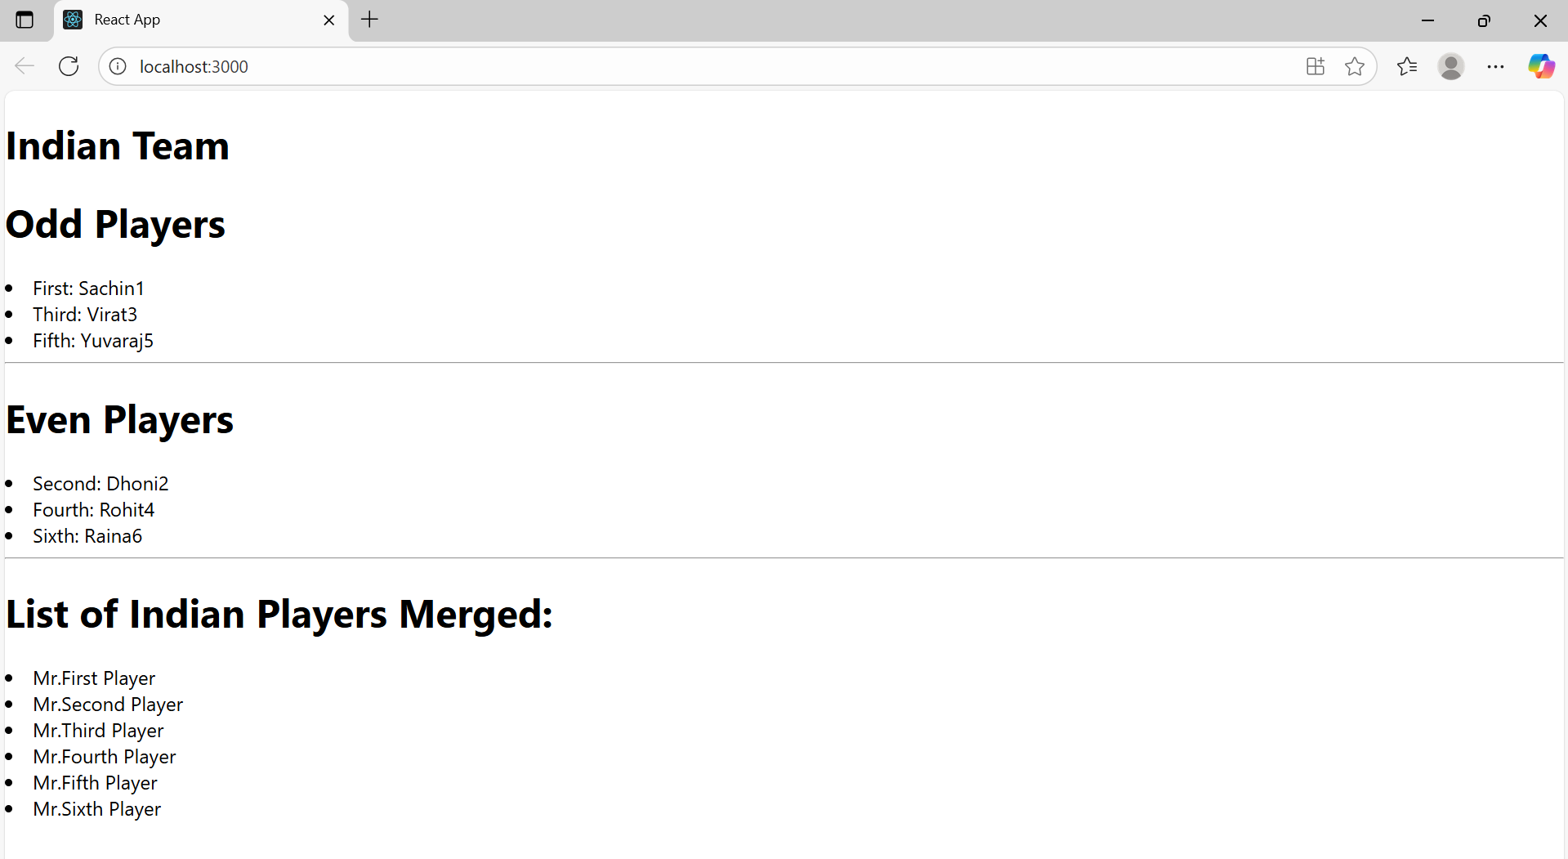

Exercise-10

Create a React Application named “officespacerentalapp” which uses React JSX to create elements, attributes and renders DOM to display the page.

Create an element to display the heading of the page.

Attribute to display the image of the office space

Create an object of office to display the details like Name, Rent and Address.

Create a list of Object and loop through the office space item to display more data.

To apply Css, Display the color of the Rent in Red if it’s below 60000 and in Green if it’s above 60000.



App.js

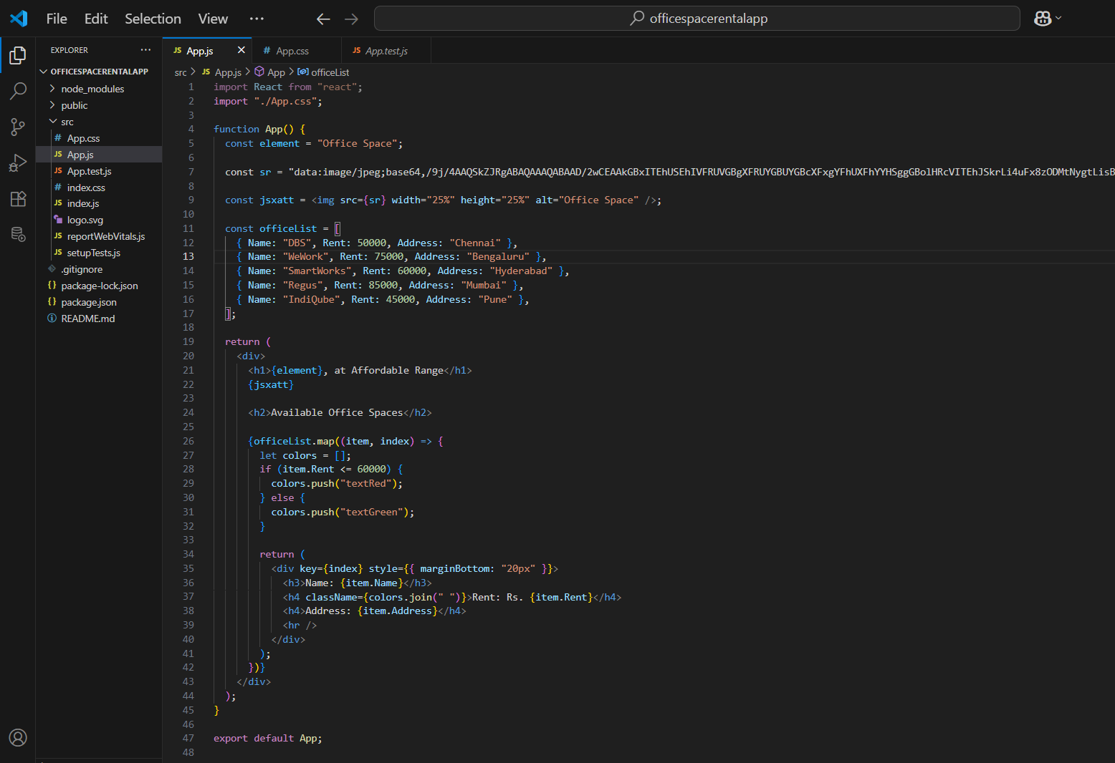

App.css

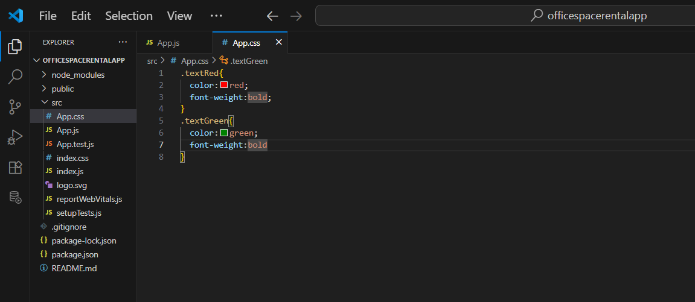

Output:

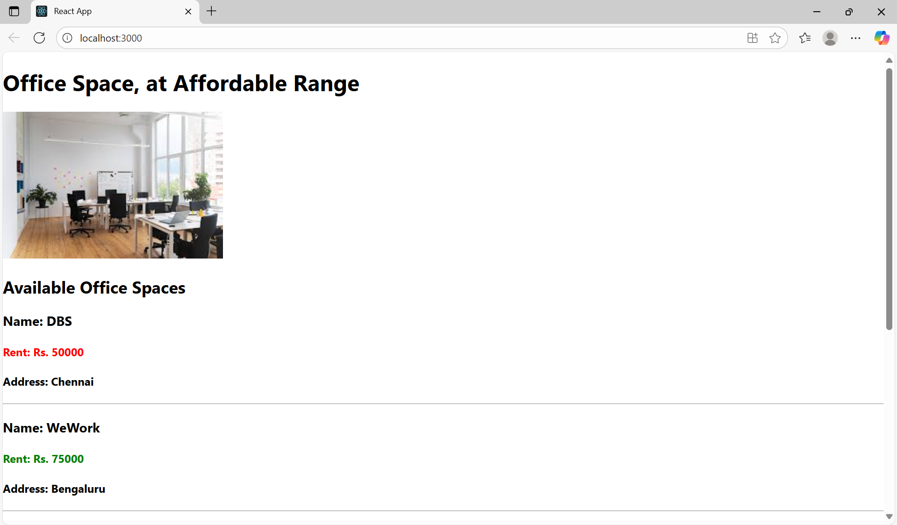

Exercise-11

Create a React Application “eventexamplesapp” to handle various events of the form elements in HTML.

1. Create “Increment” button to increase the value of the counter and “Decrement” button to decrease the value of the counter. The “Increase” button should invoke multiple methods.
   1. To increment the value
   2. Say Hello followed by a static message.



CurrencyConverter:

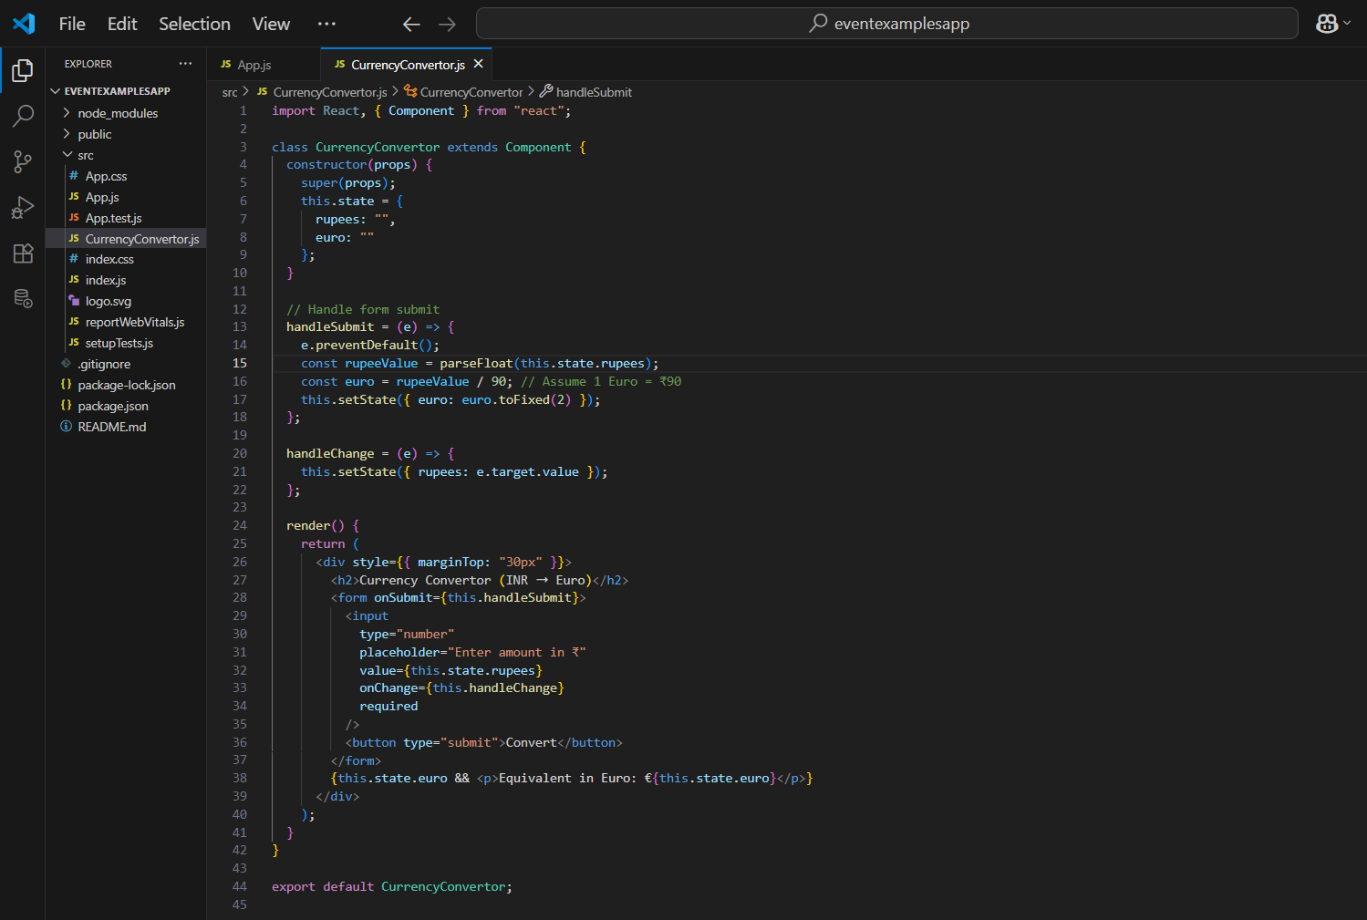

App.js

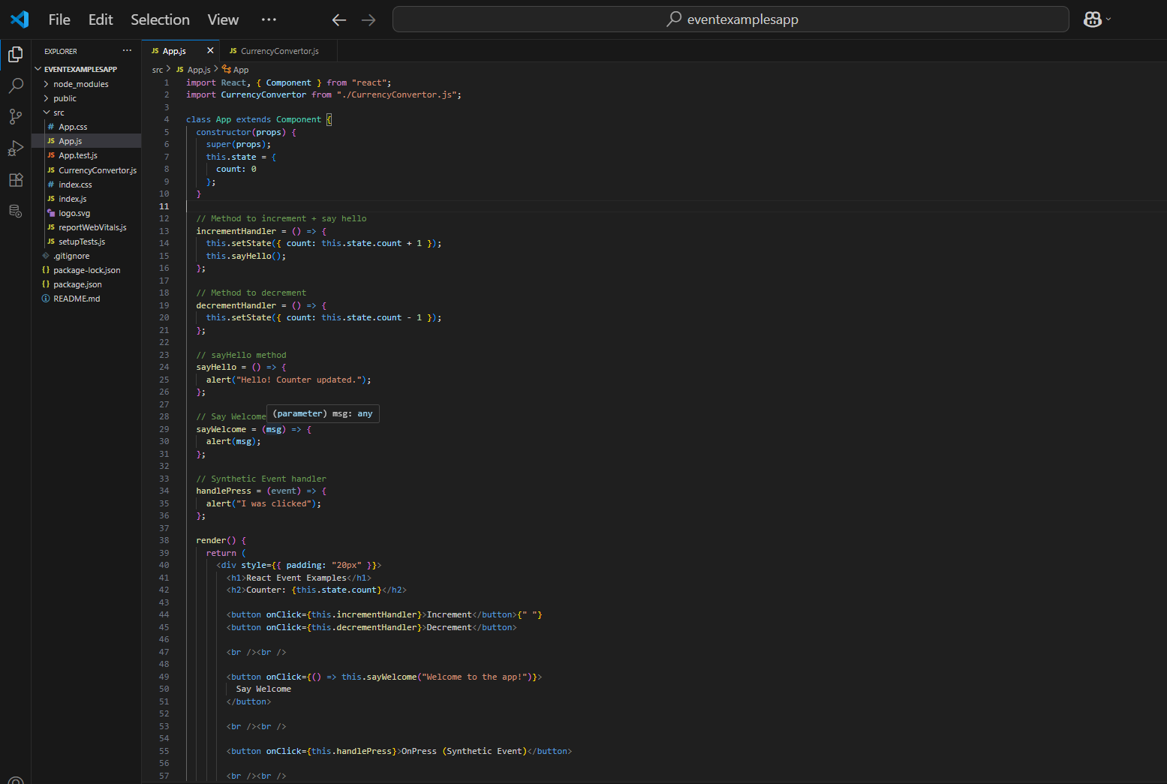

Output:

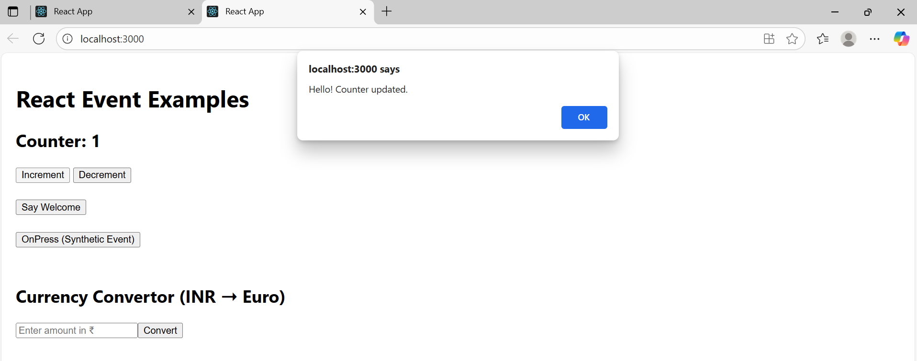

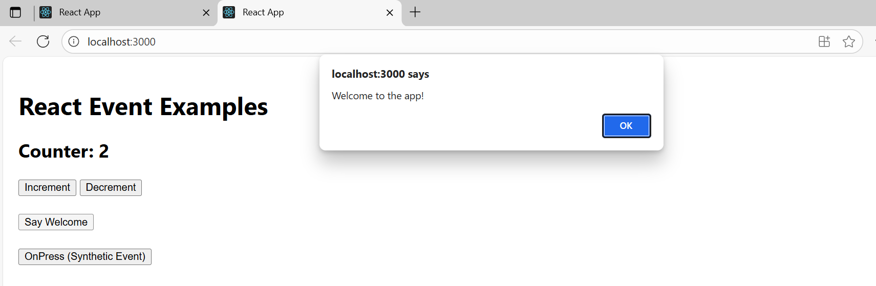

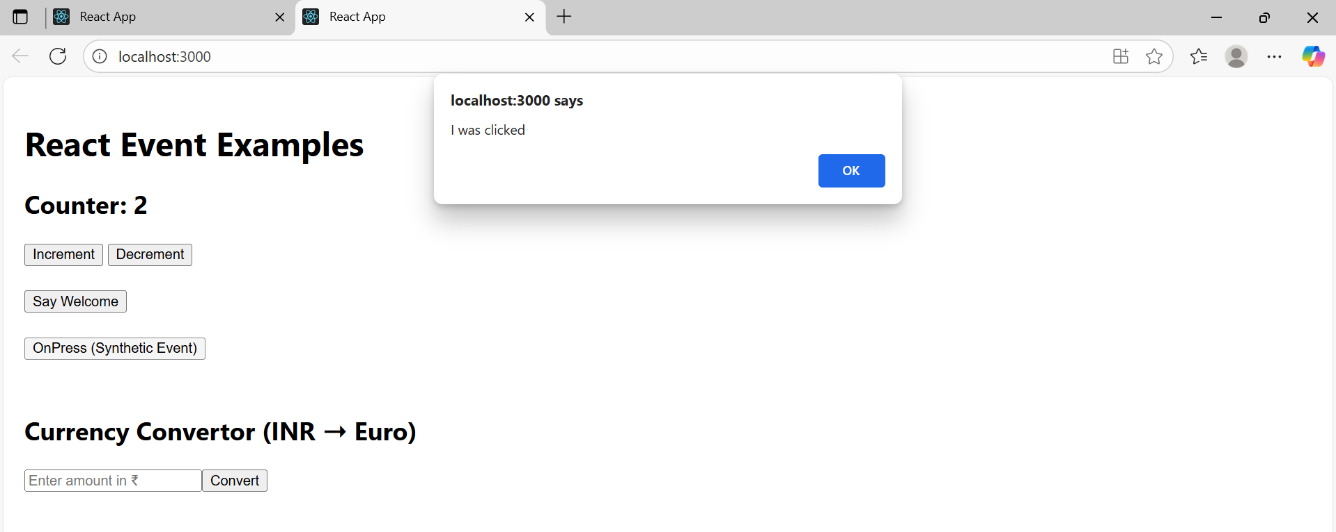

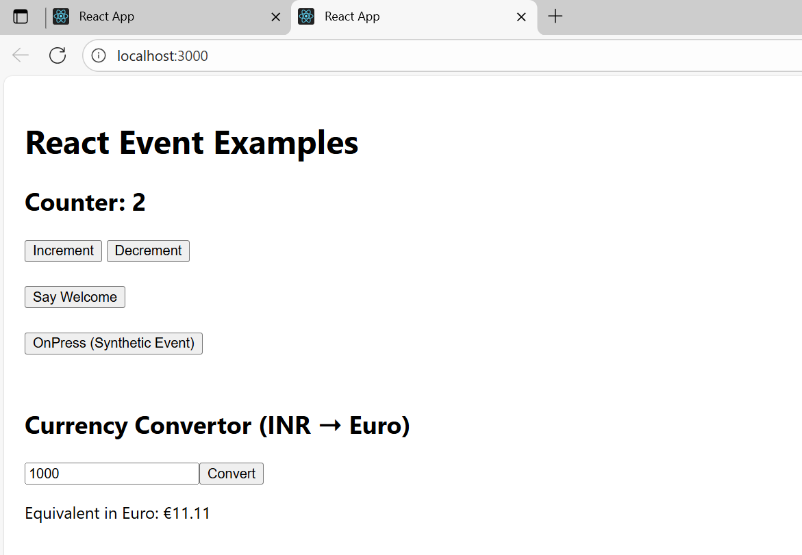

Exercise-12

Create a React Application named “ticketbookingapp” where the guest user can browse the page where the flight details are displayed whereas the logged in user only can book tickets.

The Login and Logout buttons should accordingly display different pages. Once the user is logged in the User page should be displayed. When the user clicks on Logout, the Guest page should be displayed.



UserGreeting.js

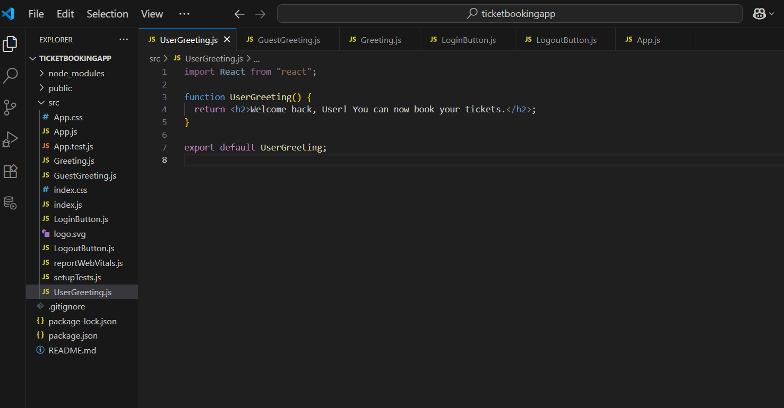

GuestGreeting.js

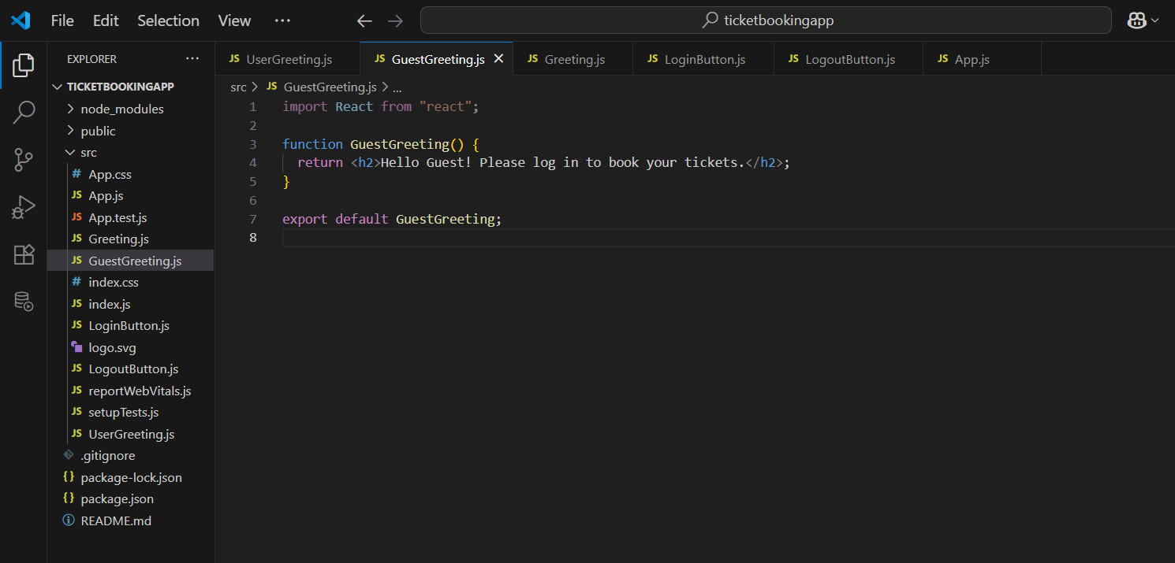

Greeting.js

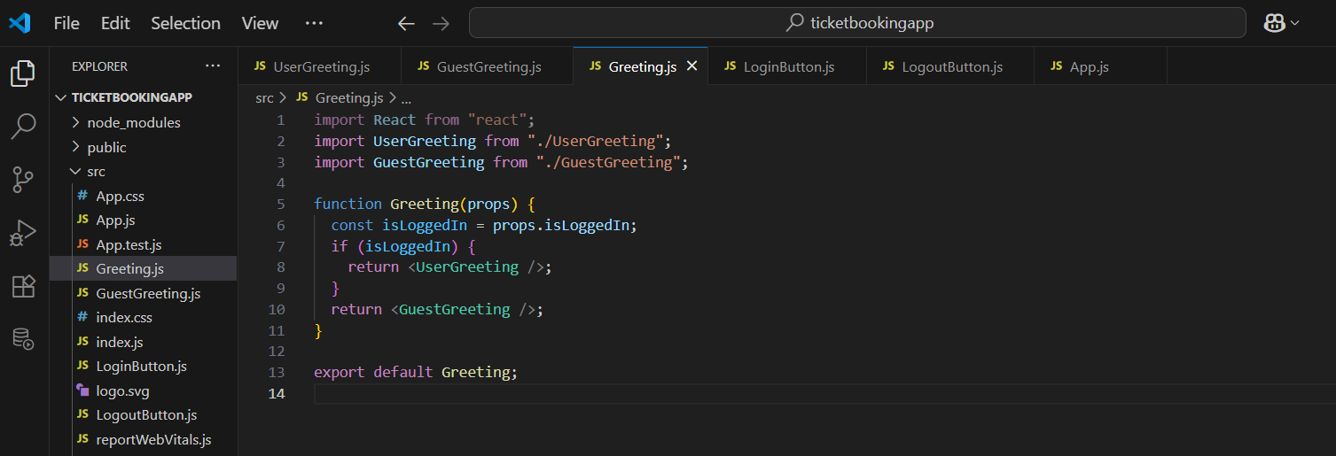

LoginButton.js

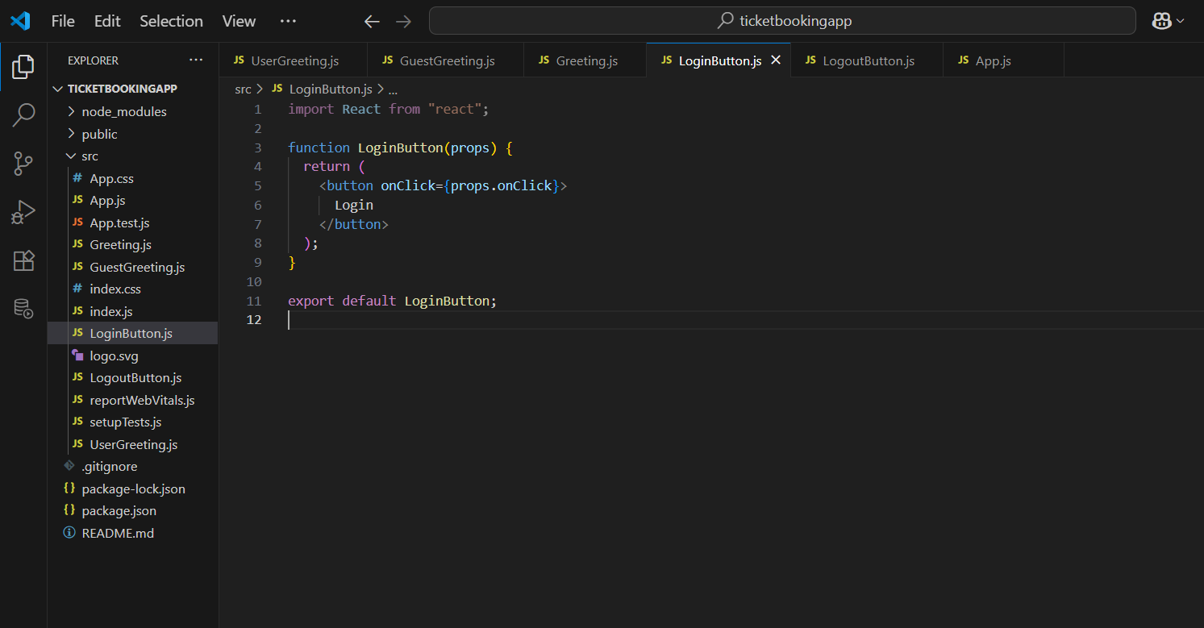

LogoutButton.js

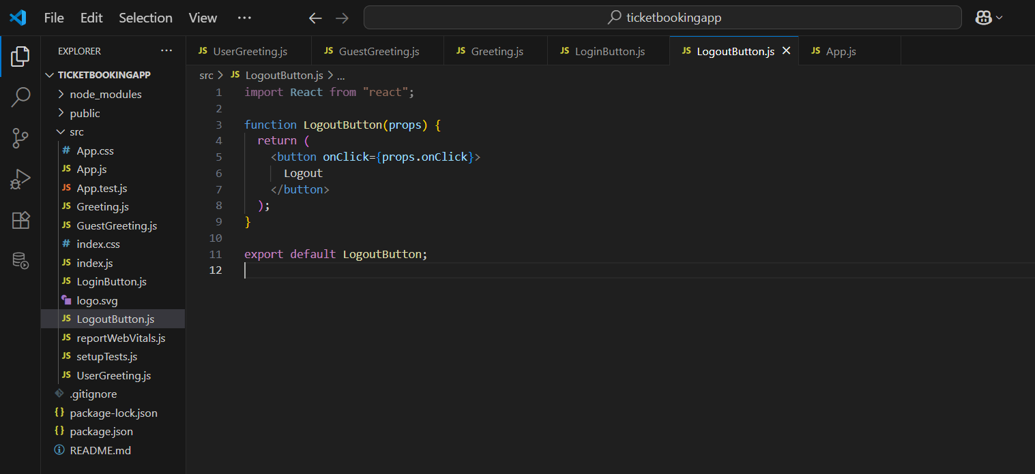

Output:

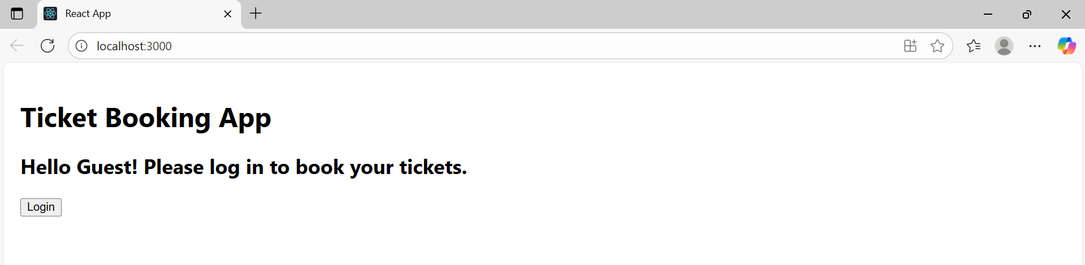

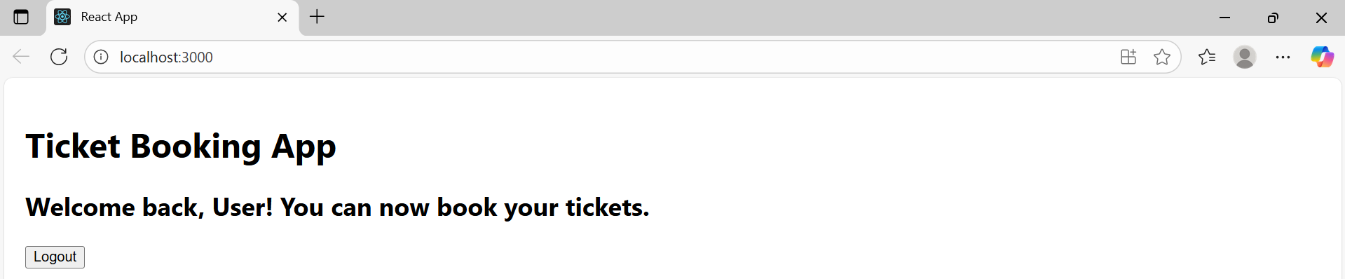

Exercise-13

Create a React App named “bloggerapp” in with 3 components.

1. Book Details
2. Blog Details
3. Course Details



BookDetails.js

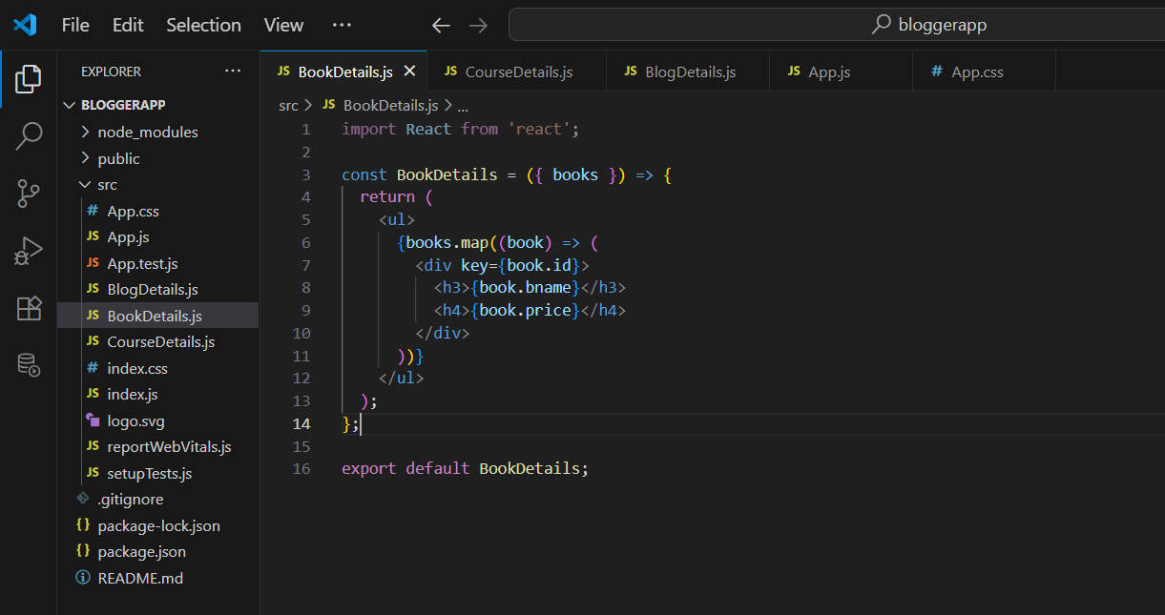

CourseDetails.js

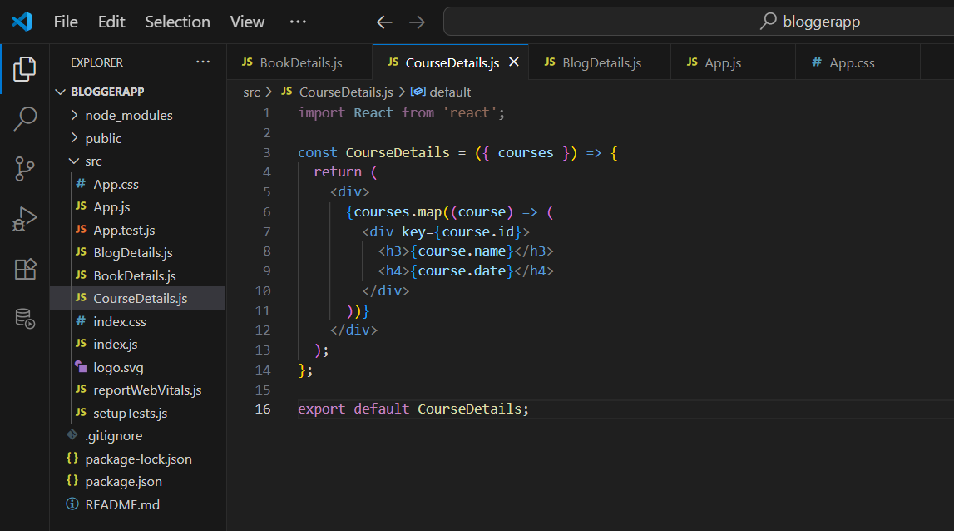

BlogDetails.js

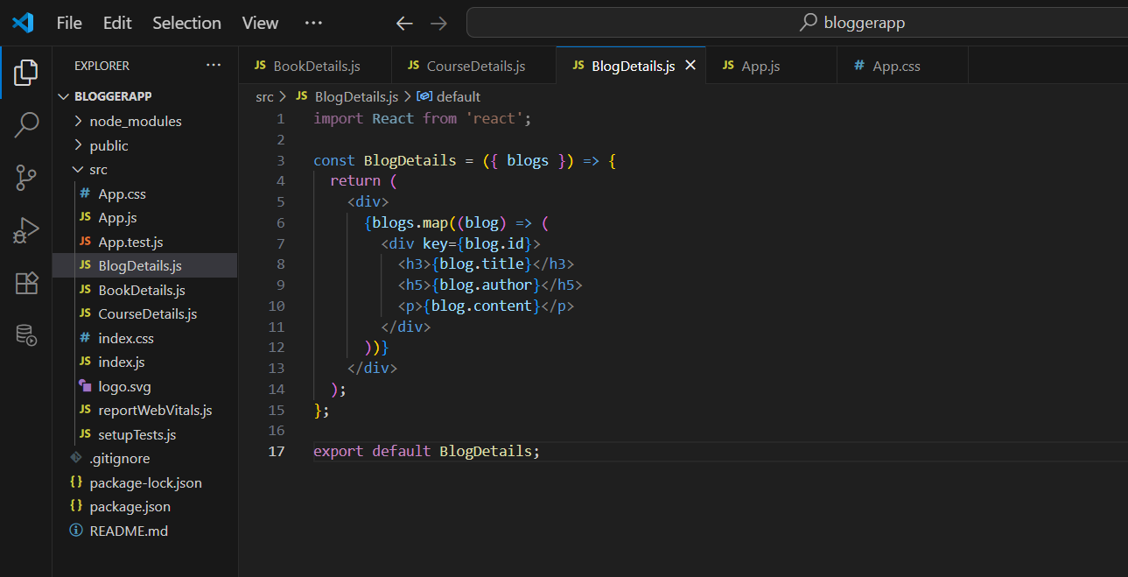

App.js

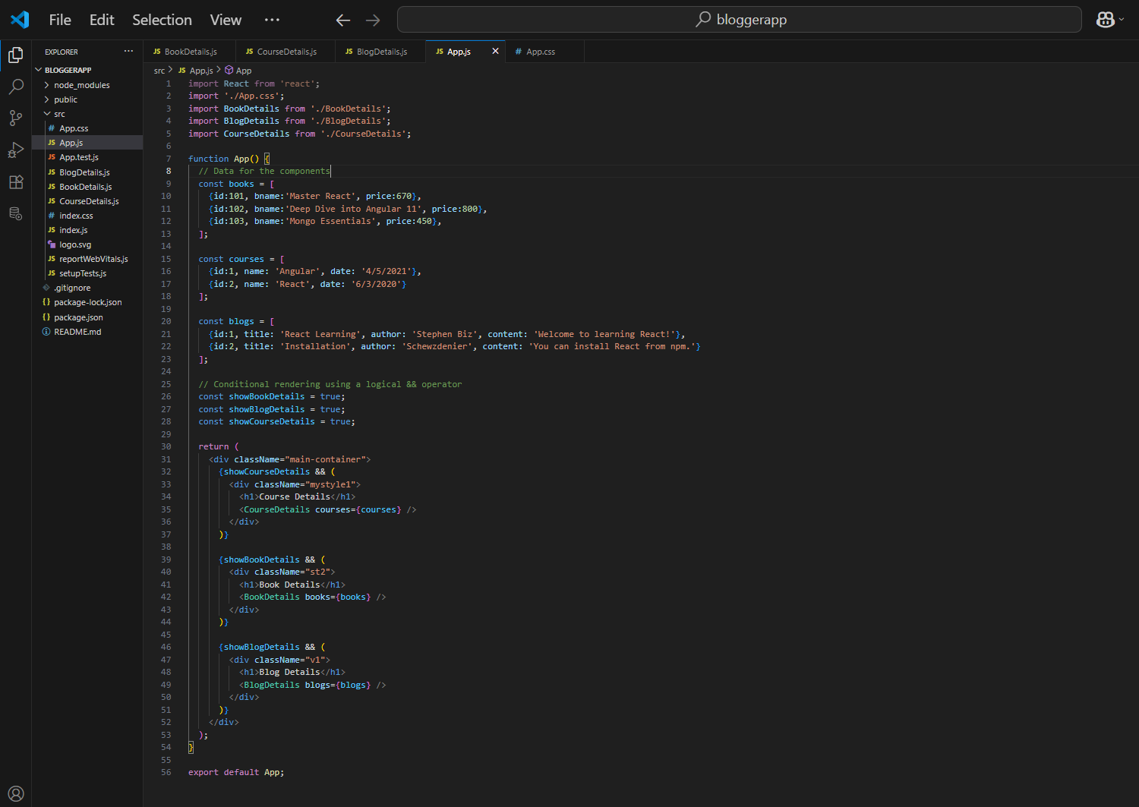

App.css

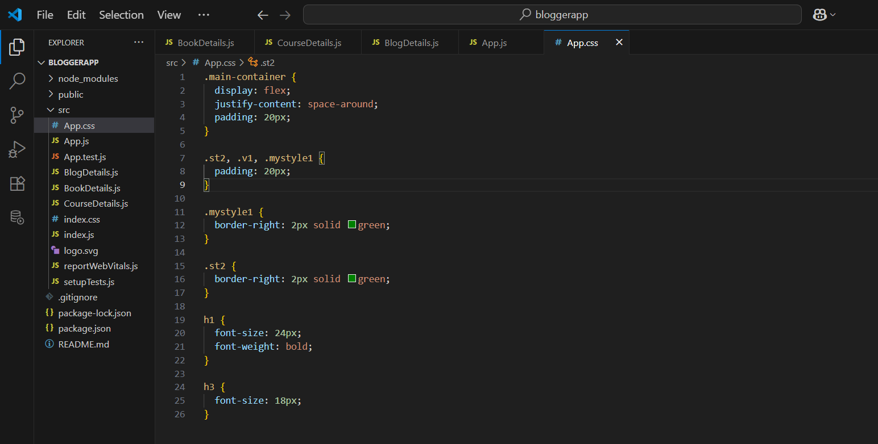

Output:

